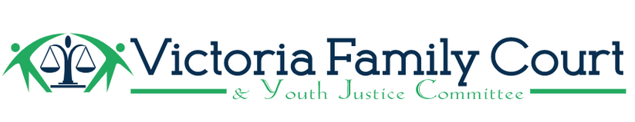
Notice of Motion – Marcie McLean, Jan. 23, 2025

“That the Victoria Family Court & Youth Justice Committee (VFC&YJC) directs the Communications sub-committee in the very near future to prepare letters to the various BC Ministers listed below but not limited to, for a Call to Action(s), to address some of the many provincial shortfalls in providing services and/or gaps in services including integrated services which indeed are the responsibility of the Province of BC for children, youth, students and their families’ at risk including but not limited to: their mental health, health, including potential addictions and addictions to illicit drugs, poverty, safety including public & community safety, education and support needs including lack of funding and/or removed funding for such provincial responsible services.

For example, services such as provided by the Mobile Youth Services Team (MYST) Criminal Reduction & Exploitation Division (CRED), through Pacific Centre Family Services Association, Victoria BC and, currently City of Victoria/Esquimalt Police Departments who function within the Greater Victoria area including Songhees and Esquimalt First Nations, as well as the Regional Domestic Violence Unit (RDVU) also involved with youth and families at risk.

And further that specific core members of VFC&YJC request to meet with the Ministers to speak to the concerns in the very near future as these matters are critical and urgent due to the current issues within the Capital Region for youth, vulnerable youth, youth at risk and their families within the Capital Regional District’”.

These future letter(s) to be sent to:
*Premier David Eby,
*Attorney General & Deputy Premier: Niki Sharma,
*Minister of Public Safety & Solicitor General: Honourable Gary Begg,
*Minister of Health: Honourable Josie Osbourne,
*Minister of Children and Family Development: Honourable Grace Lore,
*Minister of Education and Child Care: Honourable Lisa Beare,
*Minister of Indigenous Relations and Reconciliation: Honourable Christine Boyle,
*Minister of Social Development and Poverty Reduction: Honourable Sheila Malcolmson,
*Minister of Finance: Honourable: Brenda Bailey
*Minister of State for Child Care and Children and Youth with Support Needs: Honourable Jodie Wickens,
*Minister of State for Community Safety and Integrated Services: Honourable Terry Yung,

Cc: Jennifer Charlesworth, Representative for Children and Youth BC,
Cc: Integrated Police Units Regional Governance Council

